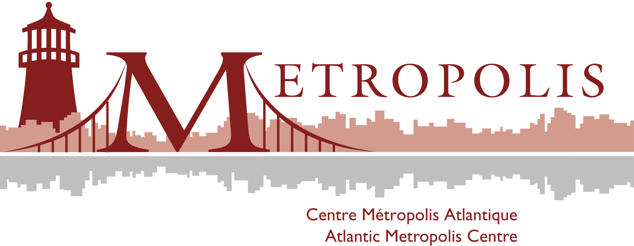

Le centre Métropolis atlantique presents a

Round Table

The University, the City and the International Students

The Atlantic Metropolis Centre is organizing a round table on the relationship between l’Université de Moncton and the Welcoming Community when it comes to the integration of international students. The main idea is to explore the changing role of universities in a context characterized by an increase in student mobility and a growing immigration tendency outside greater urban centers.
In the last ten years, universities have played a determinant role in attracting international students and they need to develop strategies that correspond to their realities and their particularities.
We have chosen to concentrate our study case on l’Université de Moncton in order to better explore the motivations behind internationalization, the strategies that are put into action, the services that are offered and also, the repercussions on municipal and provincial immigration.
By reuniting a series of actors directly implicated in such questions, the round table hopes to offer a unique reflection on integration issues concerning international students and to put forward the importance of intercommunication between different spaces of integration.
PARTICIPANTS :

Marie-Linda Lord, Vice-rectrice aux affaires étudiantes et internationales
Ben Champoux, Développement des affaires communautaires, Ville de Moncton
Chedly Belkhodja, Université de Moncton-Centre Métropolis atlantique
Michèle Vatz-Laaroussi, Université de Sherbrooke
Mohamed Ali Mhalla, Propriétaire du commerce Blue Olive
Benoît André, directeur, Centre d’accueil et d’accompagnement des immigrants du Sud-Est du Nouveau-Brunswick

9th February, 4 :30 pm
Salle 328, Édifice Taillon

For more information, please contact Chedly Belkhodja, 858-3749 or le Centre Métropolis, 858-4529.

