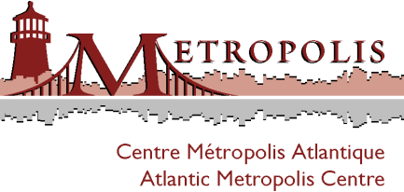

The Atlantic Metropolis Centre and UPEI
Master of Arts in Island Studies program presents:
In the Age of Profound Population Change
Dr. Michael Haan
Associate Professor and Canada Research Chair in Population and Social Policy
In 1956, Prince Edward Island had the highest fertility rates in Canada (4.6 children per woman, compared to an average of 3.9 for the rest of Canada). Today, it faces one of the country's biggest baby busts. When coupled with relatively low immigration rates, this creates an environment where population composition increasingly affects the prospects of economic growth and self-sufficiency. This talk will examine implications of such a profound population change and look at the prospects for reversing the Island’s demographic dilemma.
Michael Haan studies why immigrants make the location choices they do, and what impact these choices have on both their well-being and that of the communities they join. This research is critical to understanding the relationship between location choice and socio-economic well-being, and to preventing over-urbanization in some parts of Canada and population decline in others. Haan's earlier work focused on housing and immigration.
Friday, Dec 9, 2011, noon Main Faculty Lounge, UPEI

rsvp: lhoward@upei.ca by 6 December 2011

